**WhatsApp Pay**

**STAKEHOLDERS**

|  |  |
| --- | --- |
| **ACTOR** | **What he can do on the Software Created** |
| WhatsApp users | * Users can able to transfer money without using bank apps, NEFT or wallet * Add Bank details for One click Seamless payments. * Request for payments. * Scan QR code to make payments. |
| Banks | * Able to get details of users using the service. * Needs to collaborate with this service |
| Credit card & Debit card providers | * Collaborating with the service to attract more users * Transaction details are managed * Policies |
| WhatsApp | * Able to create more users. * Will join the digital payment apps |
| Facebook | * Additional revenue stream |

**Risk Identification**

* Payment failure risks
* Data privacy and data security risks
* Server issue risks
* Proper requirements should be communicated with all the stakeholders to avoid communication risks
* Google pay and PayPal Are competitors for this market share – Market Risk

**SWOT Analysis of WhatsApp pay**

**Strengths:**

* 2 billion users over worldwide
* Owned by Facebook
* Famous primary means of electronic communication
* Free to use

**Weakness:**

* Data privacy
* Data Security
* Work with internet only

**Opportunity:**

* Growth in global mobile payments market
* Digital payment market
* New revenue stream

**Threat:**

* Competitors like Google pay and PayPal
* Possible to hack
* Government policies

**PROPOSED SYSTEM**

To transfer money using WhatsApp pay feature

* User friendly interface
* Easy
* Seamless
* Peer to Peer Payment
* One Click Payment

**Future process Maps**

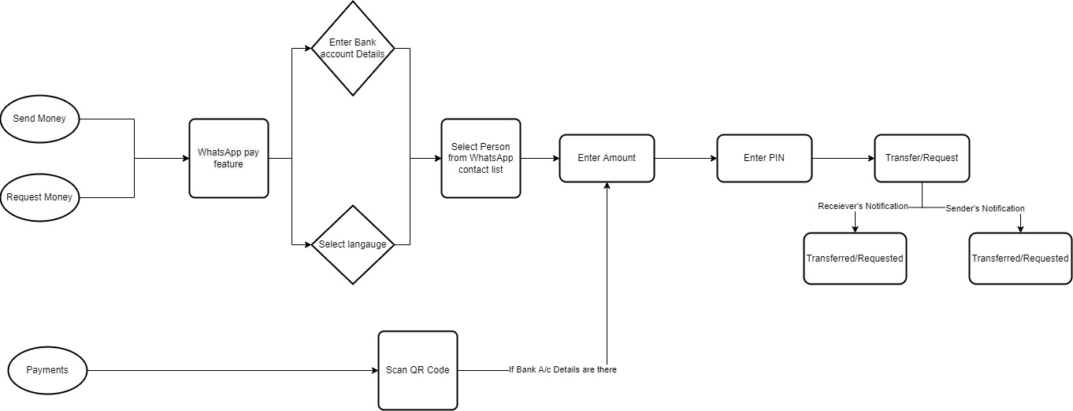

**SCOPE using Use Case Diagram (UML)**

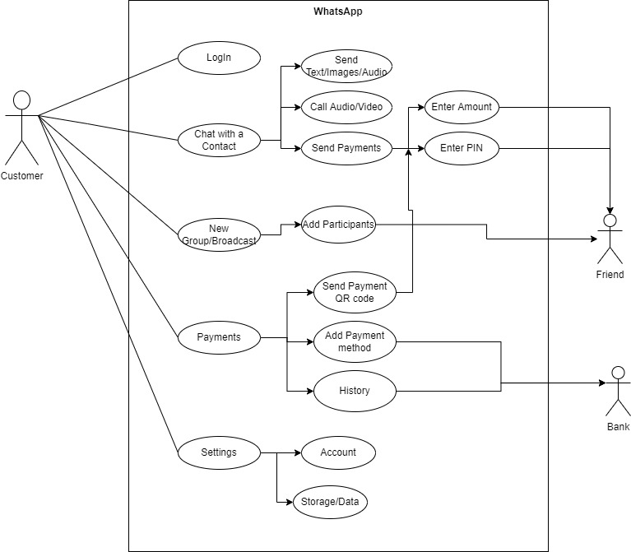

**IN SCOPE**

* Make payment
* Add bank account details for payment
* Scan QR to send money
* Create UPI PIN
* Enter UPI PIN
* Enter Amount

**OUT OF SCOPE**

* Only those can use the service who has WhatsApp, Internet banking and a Bank account also.
* After payment is done you can’t redo the transaction.
* One can’t send more money once the limit is exceeded.

**Business Requirements:**

* Making a One Click Payment gateway
* Rolling it in as an update
* Scan QR code option

**Business Objective:**

* Minimum 1 million users using WhatsApp pay feature within the first 3 months of launch.
* 30% of user base using WhatsApp pay after one year of its launch.

**FUNCTIONAL REQUIREMENTS**

* Able to make payments via WhatsApp
* Send and Accept payment request
* Scan the QR code option

**NON-FUNCTIONAL REQUIREMENTS**

* Compatibility of update
* Security of app
* Scalability of the update
* Fast and Quick payment

**System Requirement:**

* Mobile
* Desktop/Laptop/PC

**Usability:**

The screens should be:

* Unambiguous
* Straightforward options
* Easy to operated
* Easy to understand
* Accessible
* User-Friendly

**Screen Wireframes**

Wireframes for every screen that will appear to the users.

